**How to Use Attendance Tracking in Banner 9 Faculty Services (Cougar Tracks)**

1. Log into MyTC (upper right-hand corner of the TC homepage). If you need to reset your password, please contact A&R at 7741.

1. Click on the Faculty Services (Cougar Tracks) icon

1. Click on “Attendance Tracking”

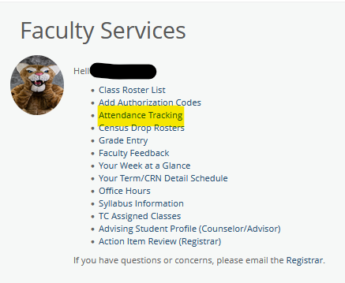

1. Click “Take Roll”. The only courses of yours that will be displayed are courses that meet in-person. Your online courses will not appear.

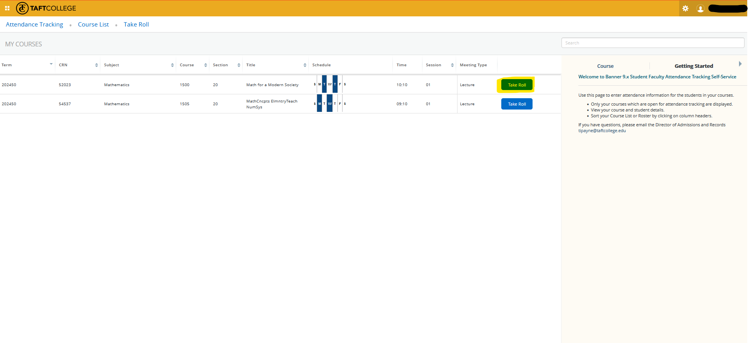

1. You will mark attendance by using the circle that is highlighted below. One click will make it green (present) and two clicks will make it red (absent). Three clicks will make it empty again. You will notice a message in the upper right corner when you changed the status. The percentage calculated is based on the days reported.

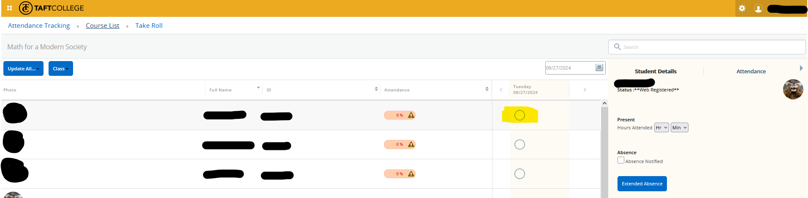

Additional Options Available to Use

Exporting Your Attendance Sheet:

1. Click on the gear icon in the upper right corner and select “Export Template”.

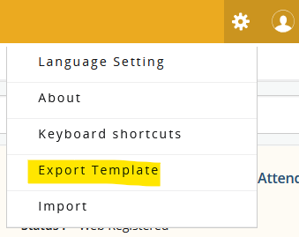

1. Select the format you want and click Export.

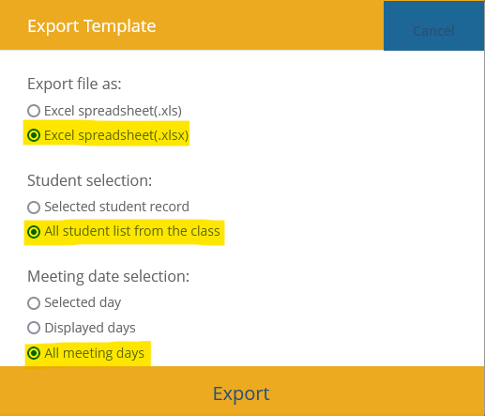

1. This will export in a format that lists all students vertically for each class meeting day. Although it is not as condensed as the old rosters, it does give you a way to track each day using a printed roster. However, you can also use the wonderful roster that Adam and Joy developed over the summer (check my email for the attachment).

Options under the “Student Details” tab: selecting the hours present from the drop-down menu, marking the “Absence Notified” button, adding a note, and entering an “Extended Absence”. If you use the “Absence Notified” button, it does not count against the percentage calculated. Think of it as an excused absence.

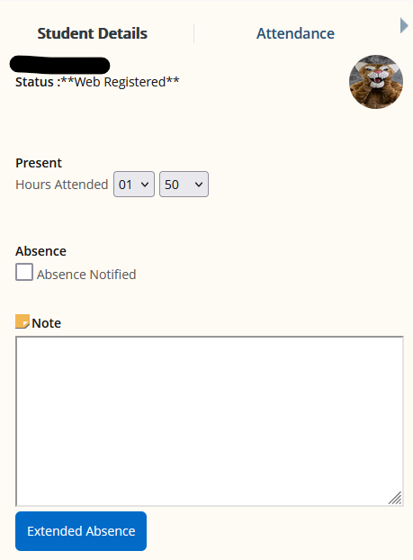

When you click the “Extended Absence” button, the window below will pop up.

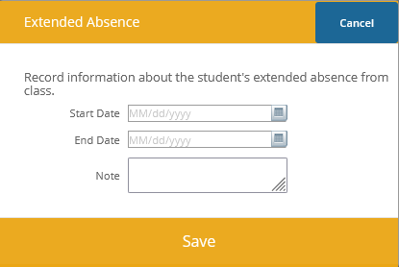

If you click on the “Attendance” tab you will see a summary of the student.

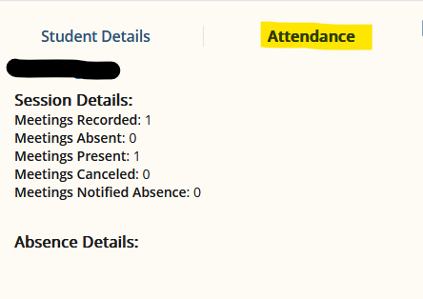

To update attendance for all students in your course, you can use the drop-down on the upper left side of the screen.

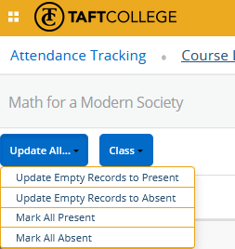

Other options that you have available for your course are below.

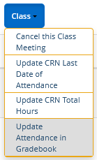

**Please do not use the cancel function until you have followed the current process with Office of Instruction regarding class cancellations.** If you “Cancel this Class Meeting” it will update all attendance with the message below and **will email all students that you have cancelled your class, but you can only do it on the day of the class in which you are cancelling**. You will notice that the students are still at 100% attendance because the class cancellation is not held against their attendance.

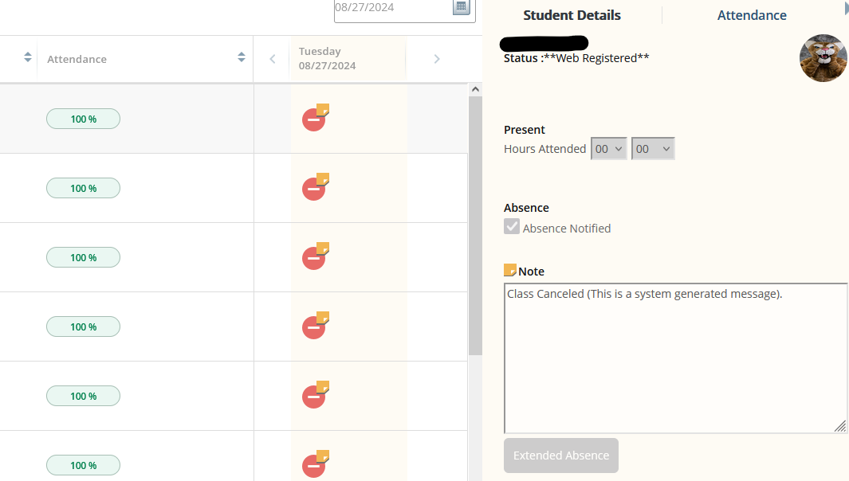

If you need to cancel the cancellation, you can click the “Reinstate this Class Meeting” button. Once you do that, it will undo the cancellation message on each student.

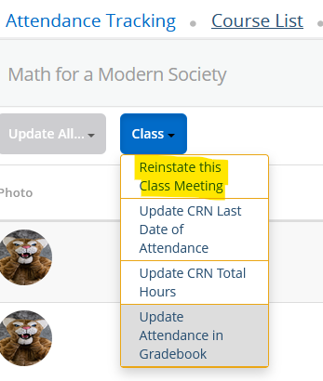

Important Things to Remember:

* Attendance Tracking is **optional for all courses besides “Arranged Hours” courses**. If you are teaching an “Arranged Hours” course, you will be notified during the first week of the term.
* This tracking is for your purposes only, it will not negatively impact a student on the back end.
* Keep in mind that you can only cancel a class meeting on the day of the class and that all students will be notified via email. **For more information regarding the process for class cancellations, please contact the Office of Instruction.**