
How to Print/Export Your Class Roster in Banner 9 Faculty Services (Cougar Tracks)
- Log into MyTC (upper right-hand corner of the TC homepage). If you need to reset your password, please contact A&R at 7741.
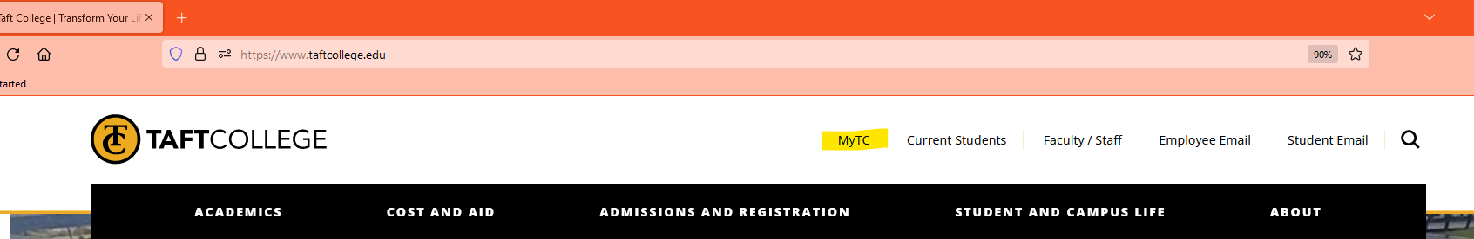

- Click on the Faculty Services (Cougar Tracks) icon
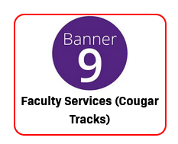
- Click on Class List
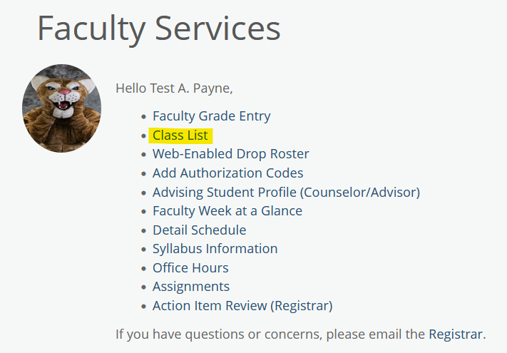
- Select the term from the drop-down menu and double click on the appropriate course.
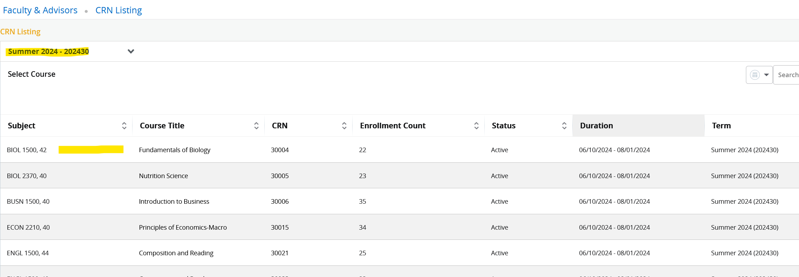
- Select Print or Export in the upper right-hand corner of your page.
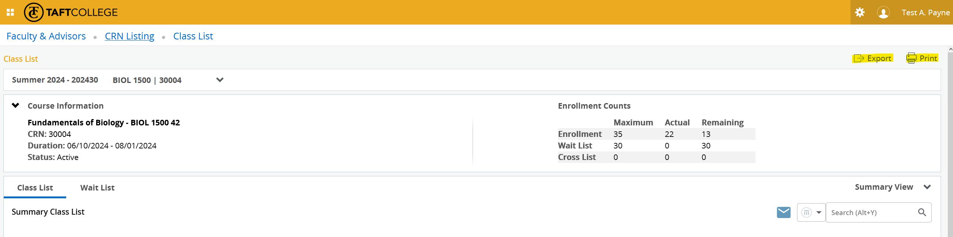

- If you select export, you will see the screen below. Click on the file type you would like and click Export.
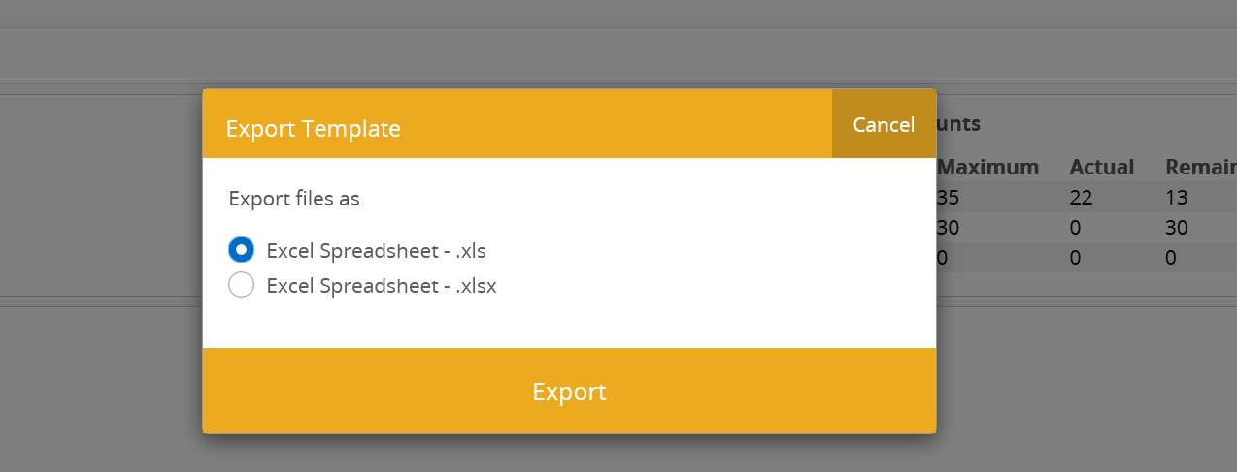

If you select Print, the printer box will open up and you will select the appropriate printer from your list of options and then click print.

Important things to remember:

- If you are following these instructions but do not see the Export or Print option in the upper right-hand corner, try zooming out. We learned during the training session that if you zoom in on your screen too far, these options do not display.

