
How to Print/Export Your Class Roster in Banner 9 Faculty Services (Cougar Tracks)
- Log into MyTC (upper right-hand corner of the TC homepage). If you need to reset your password, please contact A&R at 7741.
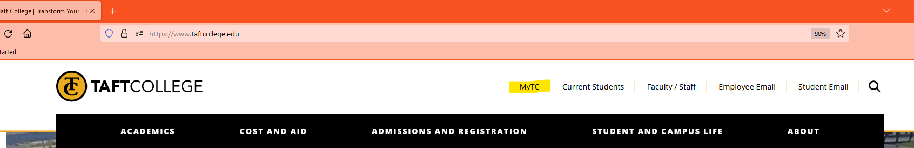

- Click on the Faculty Services (Cougar Tracks) icon
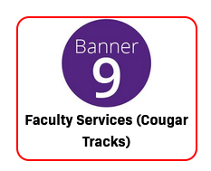
- Click on Class List
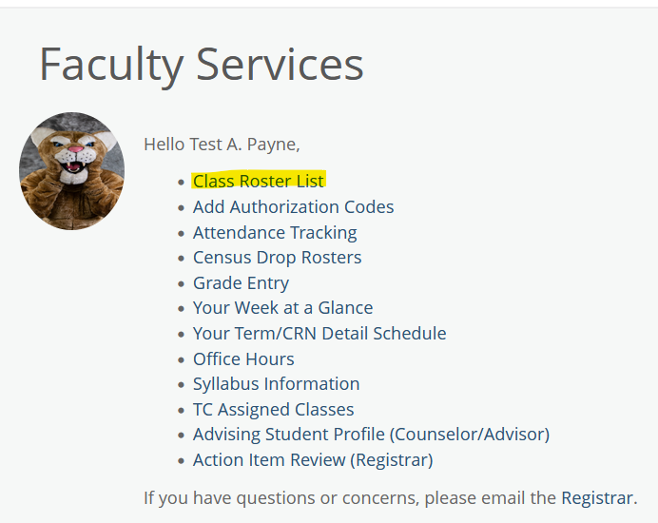
- Select the term from the drop-down menu and double click on the appropriate course.
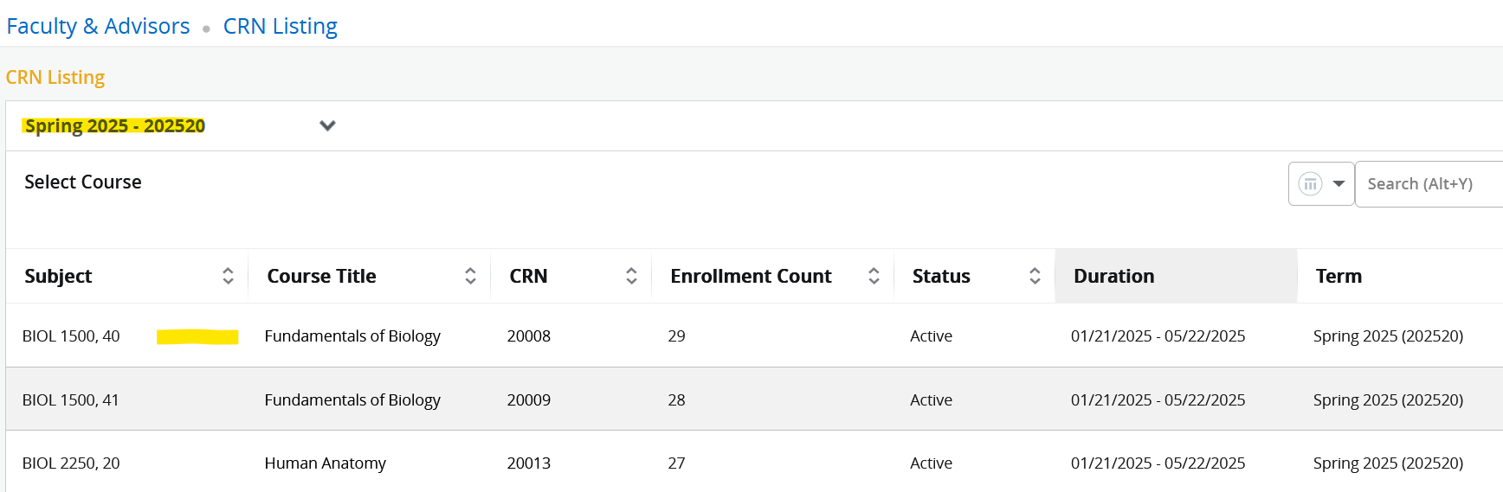
- Select Print on upper right-hand corner of your page.
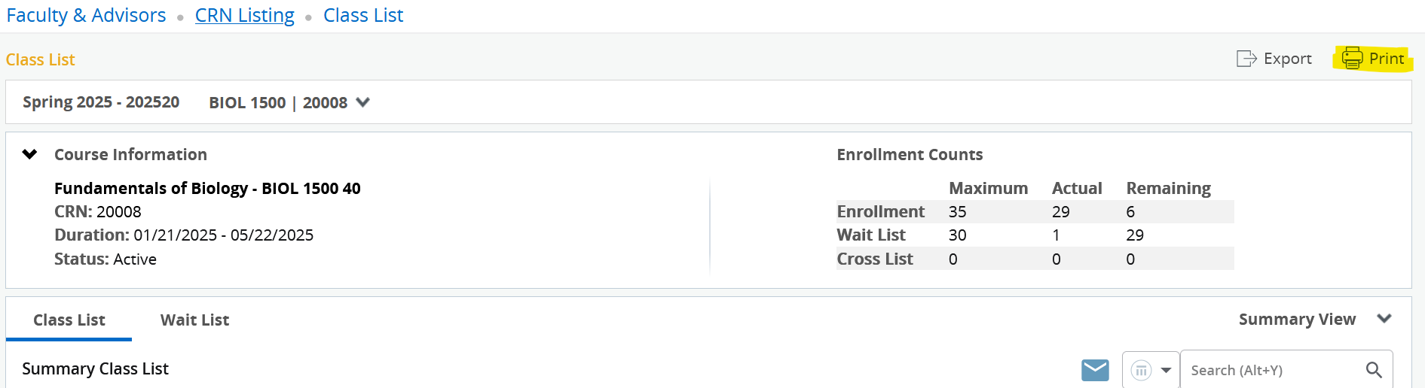

The printer box will open up and you will select the appropriate printer from your list of options and then click print. You can print to Adobe PDF and then add text and sign/date electronically. You can also print it out and write the appropriate notations then sign/ date. Once completed, please email the paper roster to us at records@taftcollege.edu and CC the Director of Admissions and Records. You may also bring the paper in to our office and we will scan for our records.

Important things to remember:

- If you are following these instructions but do not see the Print option in the upper right-hand corner, try zooming out. We learned during the training session that if you zoom in on your screen too far, these options do not display.
- If the student did not attend at all, indicate “NS” or “No Show” next to their name.
- If the student did attend and stopped attending, indicate “ID” or “Instructor Drop” with the last date of attendance next to their name.

