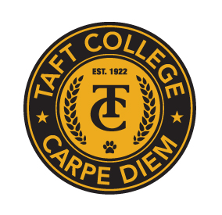**TAFT COLLEGE**

**Governance Council**

**January 24, 2025**

**10:10 a.m. – 12:00 p.m.   
Cougar Room**

# **AGENDA**

**Facilitator: Candace Duron**

**Timekeeper: Heather del Rosario**

**Recorder/Minutes: Brandy Young**

1. Approval of Minutes – November 15, 2024 **(Action Item)**  5 Minutes

1. Committee Reports 40 Minutes
   1. Strategic Enrollment (SEMCOM) (Leslie Minor)
   2. Budget Committee (Mike Giacomini)
   3. Strategic Planning Committee (Xiaohong Li)
   4. Campus Safety and Security (Heather del Rosario)
   5. Information Technology (Xiaohong Li)  
      * Charter and Self-Evaluation **(Action Items)**
   6. DEIAA Committee (Leslie Minor)
   7. Academic Senate (Candace Duron)
2. Educational Master Plan Development Update (Xiaohong Li) 10 Minutes
   1. Six-Hour Goal Setting Session – February 13, 2025
3. Accreditation Mid-Term Report (Xiaohong Li) 15 Minutes
   1. Reflections on Continuous Improvement
4. Mission Statement Review Process (Xiaohong Li) **(Action Item)**  10 Minutes
5. ACCJC Substantive Change – Distance Education Update (Xiaohong Li) 5 Minutes
6. Other

**Next Meeting: February 13, 2025 – Educational Master Plan Goal Setting Session**

**Cougar Room – 8:00 a.m. to 3:00 p.m. (Lunch will be provided)**