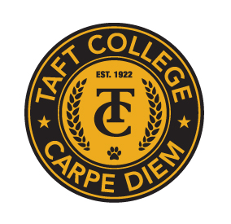**TAFT COLLEGE**

**Governance Council**

**April 11, 2025**

**10:10 a.m. – 12:00 p.m.   
Cougar Room**

# **AGENDA**

**Facilitator: Xiaohong Li**

**Timekeeper: Justin Madding**

**Recorder/Minutes: Brandy Young**

1. Approval of Minutes – March 21, 2025 **(Action Item)**  5 Minutes

1. Committee Reports 35 Minutes
   1. Strategic Enrollment (SEMCOM) (Leslie Minor)
   2. Budget Committee (Mike Giacomini)
   3. Strategic Planning Committee (Xiaohong Li)
   4. Campus Safety and Security (Heather del Rosario)
   5. Information Technology (Xiaohong Li)
   6. DEIAA Committee (Leslie Minor)
   7. Academic Senate (Candace Duron)
2. Student Survey Presentation (Krystal Allikas) 20 Minutes
3. Educational Master Plan **(Action)** 10 Minutes
4. Evaluating the Impact of Program Review Funded Items (Xiaohong Li) 10 Minutes
5. Budget Presentation (Mike Giacomini)  35 Minutes
6. Board Policy 2510 (Leslie Minor) 5 Minutes

**Next Meeting: May 15, 2025 – Cougar Room – 10:10 a.m. to 12:00 p.m.**