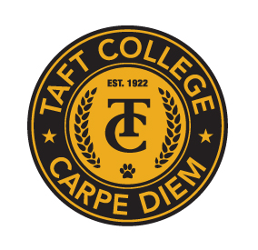**TAFT COLLEGE**

**Governance Council**

**November 15, 2024**

**10:10 a.m. – 12:00 p.m.   
Cougar Room**

# **AGENDA**

**Facilitator: Todd Hampton**

**Timekeeper: Justin Madding**

**Recorder/Minutes: Brandy Young**

1. Approval of Minutes – September 20, 2024 **(Action Item)**  5 Minutes
2. Educational Master Plan Development Update (Xiaohong Li) 5 Minutes

1. Committee Reports 40 Minutes
   1. Strategic Enrollment (SEMCOM) (Leslie Minor)
      1. SEMCOM Charter and Self-Evaluation **(Action Items)**
   2. Budget Committee (Todd Hampton)
      1. Budget Committee Charter and Self-Evaluation **(Action Items)**
      2. Budget Development Calendar **(Action Item)**
   3. Strategic Planning Committee (Xiaohong Li)
      1. SPC Charter and Self-Evaluation **(Action Items)**
   4. Campus Safety and Security (Heather del Rosario)
   5. Information Technology (Xiaohong Li)
   6. DEIAA Committee (Leslie Minor)
      1. DEIAA Charter and Self-Evaluation **(Action Items)**
   7. Academic Senate (Candace Duron)
2. Accreditation Mid-Term Report – Due October 25, 2025 15 Minutes
   1. Timeline **(Action Item)**
   2. Reflections on Continuous Improvement
3. Accreditation Substantive Change (Xiaohong Li) 5 Minutes
4. Other

**Next Meeting: December 13, 2024, in Cougar Room**