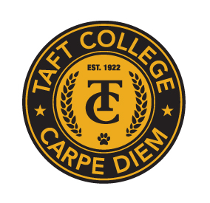**TAFT COLLEGE**

**Governance Council**

January 19, 2024

10:10 am Cougar Room

# AGENDA

Facilitator: Bill Devine

Timekeeper: Brandy Young

Recorder/Minutes: Sarah Criss

1. Approval of Minutes from December 8, 2023 Meeting 5 Minutes

1. Committee Reports (Brief Updates) 40 Minutes
   1. SEMCOM Committee (Damon Bell/Leslie Minor)
   2. Budget Committee (Todd Hampton)
   3. Strategic Planning Committee (Xiaohong Li)
   4. Campus Safety and Security (Heather del Rosario)
   5. Information Technology (Xiaohong Li)
   6. DEIAA Committee (Damon Bell)
   7. Academic Senate (Candace Duron)
2. Community College Student Survey of Engagement (CCSSE) 10 Minutes

1. Program Review Report 15 Minutes
2. Other 5 Minutes

Next Meeting - Facilitator: Timekeeper:

Next Meeting: February 9th, 10:10 am in the Cougar Room