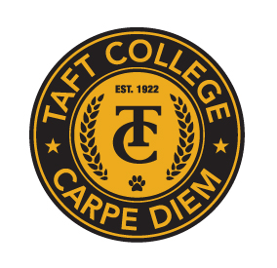**TAFT COLLEGE**

**Governance Council**

October 20, 2023

10:10 am Cougar Room

# AGENDA

Facilitator: Leslie Minor

Timekeeper: Mike Mayfield

Recorder/Minutes: Sarah Criss

1. Approval of Minutes from September 15, 2023 Meeting 5 Minutes

1. Committee Reports (Brief Updates) 40 Minutes
   1. SEMCOM Committee (Damon Bell/Leslie Minor)
   2. Budget Committee (Todd Hampton)
   3. Strategic Planning Committee (Xiaohong Li)
   4. Campus Safety and Security (Heather del Rosario)
   5. Information Technology (Xiaohong Li)
   6. DEIAA Committee (Damon Bell)
   7. Academic Senate (Candace Duron)
2. 2023-2024 Budget Development Calendar (Todd Hampton) 10 Minutes
3. Governance Council Charter 10 Minutes
4. Committee Charter 15 Minutes
   1. Budget Committee (Todd Hampton)
   2. Strategic Planning Committee (Xiaohong Li)
5. Committee Self-Evaluation 10 Minutes
   1. Budget Committee (Todd Hampton)
6. Program Review Contact List – Faculty/Division Chair 15 Minutes
7. Other 5 Minutes

Next Meeting - Facilitator: Timekeeper:

Next Meeting: November 17th, 10:10 am in the Cougar Room