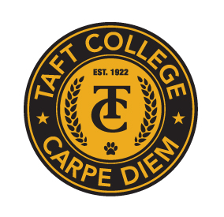**TAFT COLLEGE**

**Governance Council**

March 15, 2024

10:10 am Cougar Room

# AGENDA

Facilitator: Adam Bledsoe

Timekeeper: Damon Bell

Recorder/Minutes: Sarah Criss

1. Approval of Minutes from February 9, 2024 and January 19, 2024 Meeting 5 Minutes

1. Committee Reports (Brief Updates) 40 Minutes
   1. SEMCOM Committee (Damon Bell/Leslie Minor)
   2. Budget Committee (Todd Hampton)
   3. Strategic Planning Committee (Xiaohong Li)
   4. Campus Safety and Security (Heather del Rosario)
   5. Information Technology (Xiaohong Li)
   6. DEIAA Committee (Damon Bell)
   7. Academic Senate (Candace Duron)
2. OER Strategic Plan (Oja) 15 Minutes

1. SAP 2022-23 Data Update (Li) 15 Minutes
2. Evaluating the impact of PR based resource allocation for 2021-22 (Li) 10 Minutes
3. Approve ACCJC Annual Report (Li) 10 Minutes
4. 2023-24 Goal Scoring Worksheet (Li) 10 Minutes
5. Other 5 Minutes

Next Meeting - Facilitator: Timekeeper:

Next Meeting: April 19th, 10:10 am in the Cougar Room